Ways to get Children Excited about History
Learning history in schools can sometimes be seen as memorising and regurgitating sequences of events, names, and dates. With access to historical landmarks, books, and toys, there is a huge variety in how we children can learn to love history!

1.) Play Dress Up
Allow children to experience history first-hand by allowing them to dress up as historical characters. Through this, children will be able to connect with history and also act out famous scenes they are learning about at school. There are plenty of costumes that can be easily sourced at home such as a Victorian child or Roman toga. This is a creative way for your child to learn about how historical figures lived.
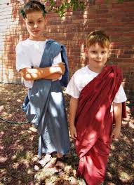

2.) Immerse Yourself in Historical Fiction
There's so much historical fiction available to immerse children into a past world. Visit the historical fiction section of your local library to discover the vast range of stories available that can transport your children into the history they will be learning about in schools. Covering everything from the ancient Egyptians to the Romans, children will be able to connect with these worlds through literature.
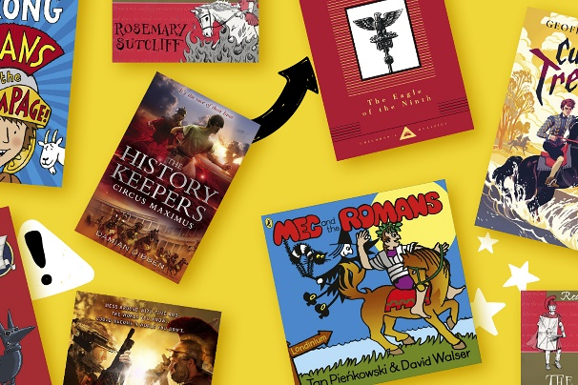

3.) Visit Museums
Museums are fun days out for the whole family to see and experience history. Seeing history in this environment makes it more real. In museums, children can explore artefacts from the past, including clothing, tools, and other artefacts. Help your child engage with their learning by encouraging them to record what they have seen.
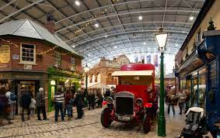

4) Historical Family Games
Get the whole family involved by playing a historical board game. This way children can learn with their family and friends in a way that is fun and a little competitive!
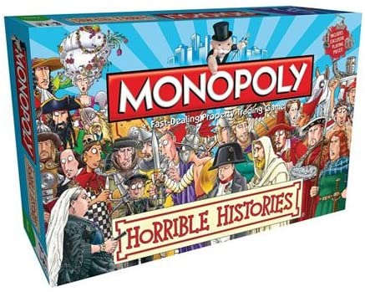

5.) Investigate Your Own Family Tree
Take a look at your own family's history. Recounting stories of children's ancestors connects them to the past and allows them to see where they came from. Photos and documents from past relatives can allow your child to visually learn about their own place in history. Allow your children to discuss with grandparents and older relatives about their lives and how times have changed. Once they have gathered this information, they can build a family tree!
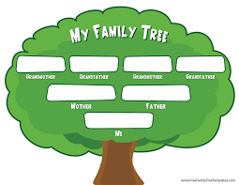

6.) Learn Through Play
There are plenty of historical toys available. Dinosaurs and soldiers are popular toys within the home. Use these to teach your child about the history behind them. This way you are using items your child already loves as learning tools!


